DATA ANALYTICS WITH TABLEAU

ASSIGNMENT – 2

O.Kusuma

VNITSW

B.Tech(CSE)-4

20NN1A0536

1.DONUT CHART 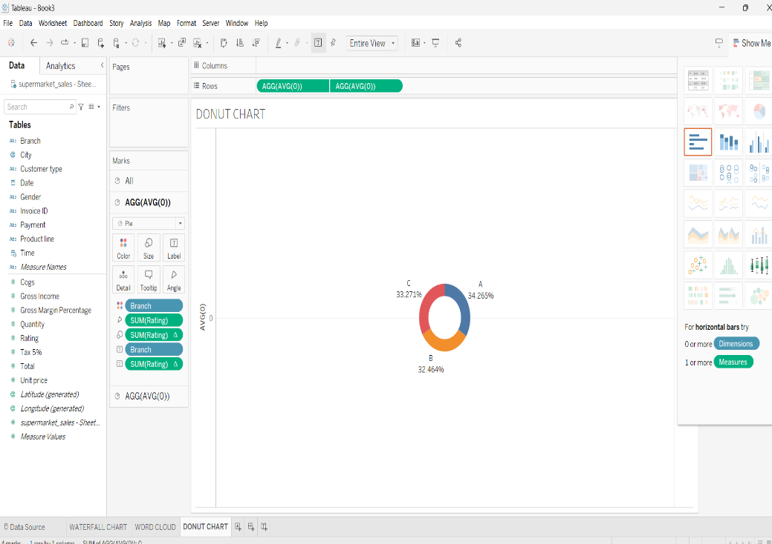

2.AREA CHART

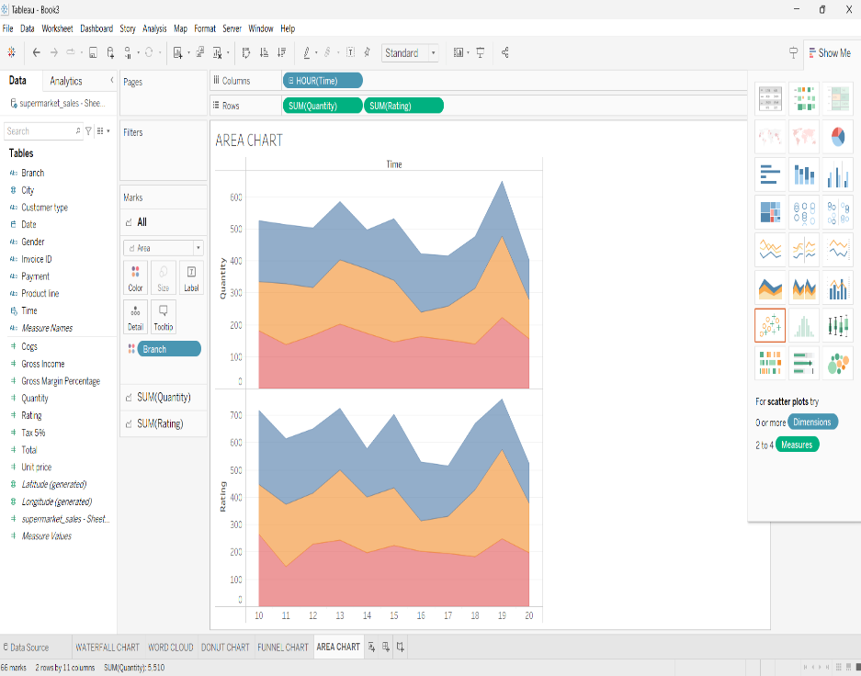

3.TEXT TABLE

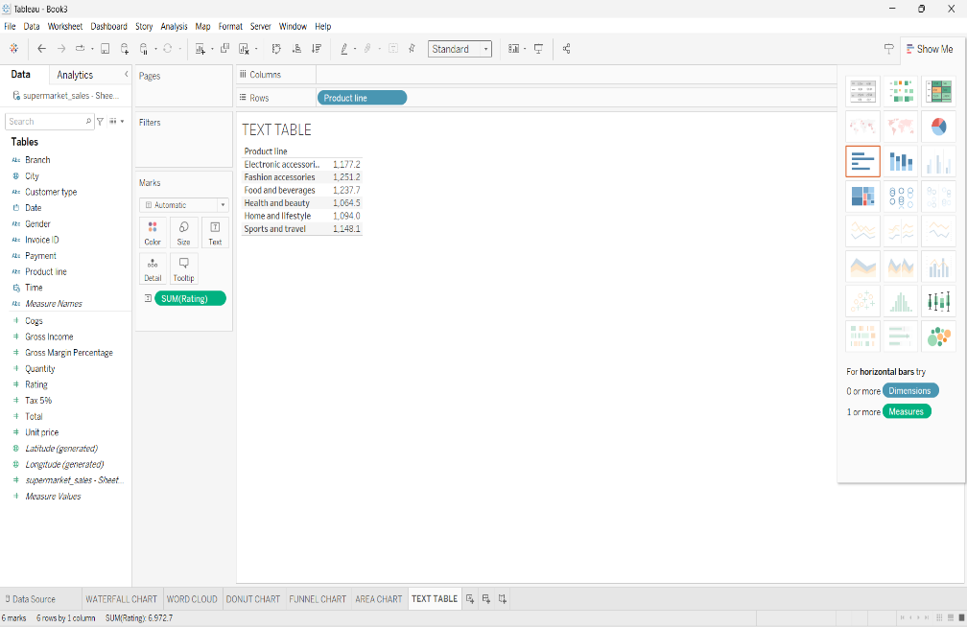

4.HIGHLIGHTED TABLE

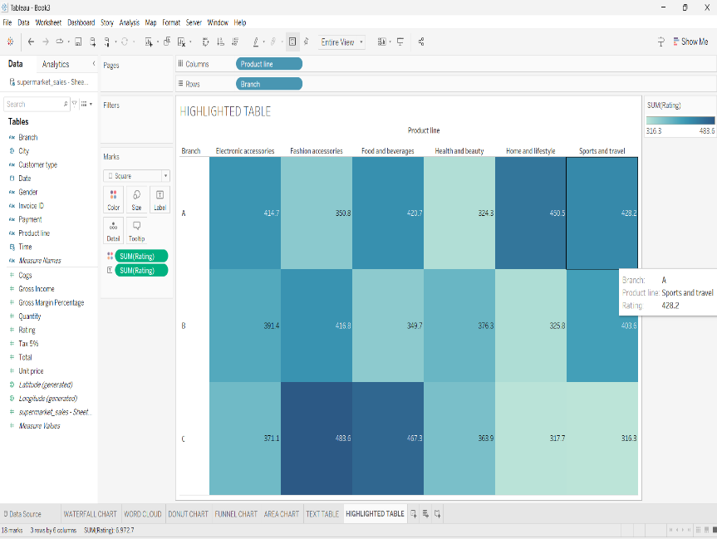

5.WORD CLOUD

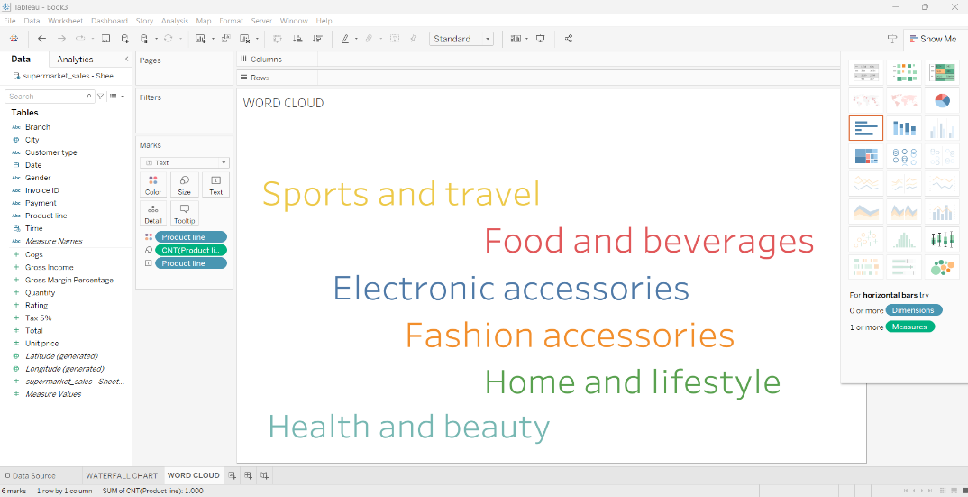

6.FUNNEL CHART

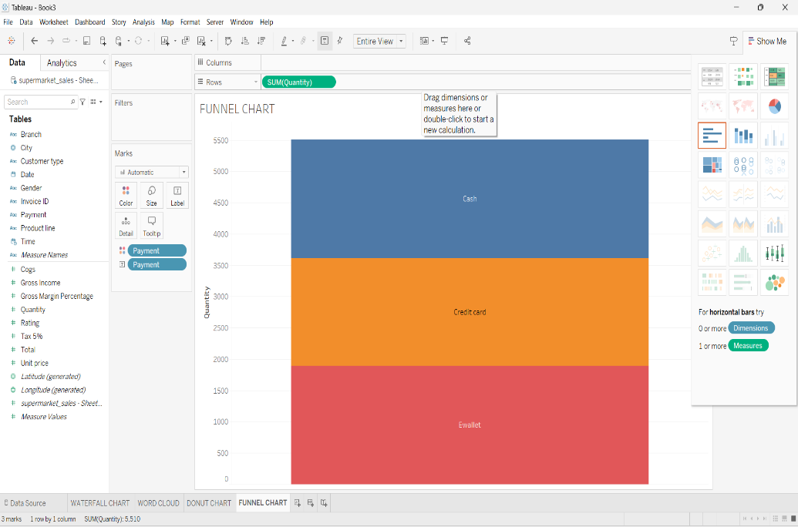

7.WATERFALL CHART

